

***Dism Project Documentation***

**Faculty**: **Shaikh Faizan Hasan**

**Group Members:**

Abdul Rehman ( 1413839 )

M. Huzaifa Khan (1412999 )

Abdul Rehman ( 1413030 )

**Add Category:**

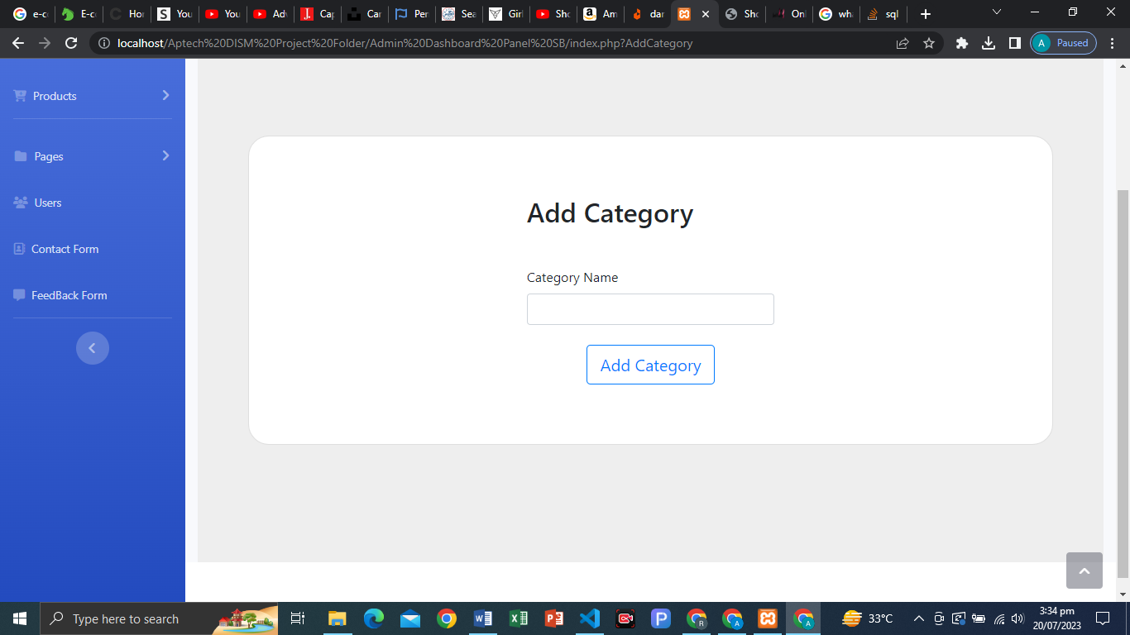

**Structure Coding:**

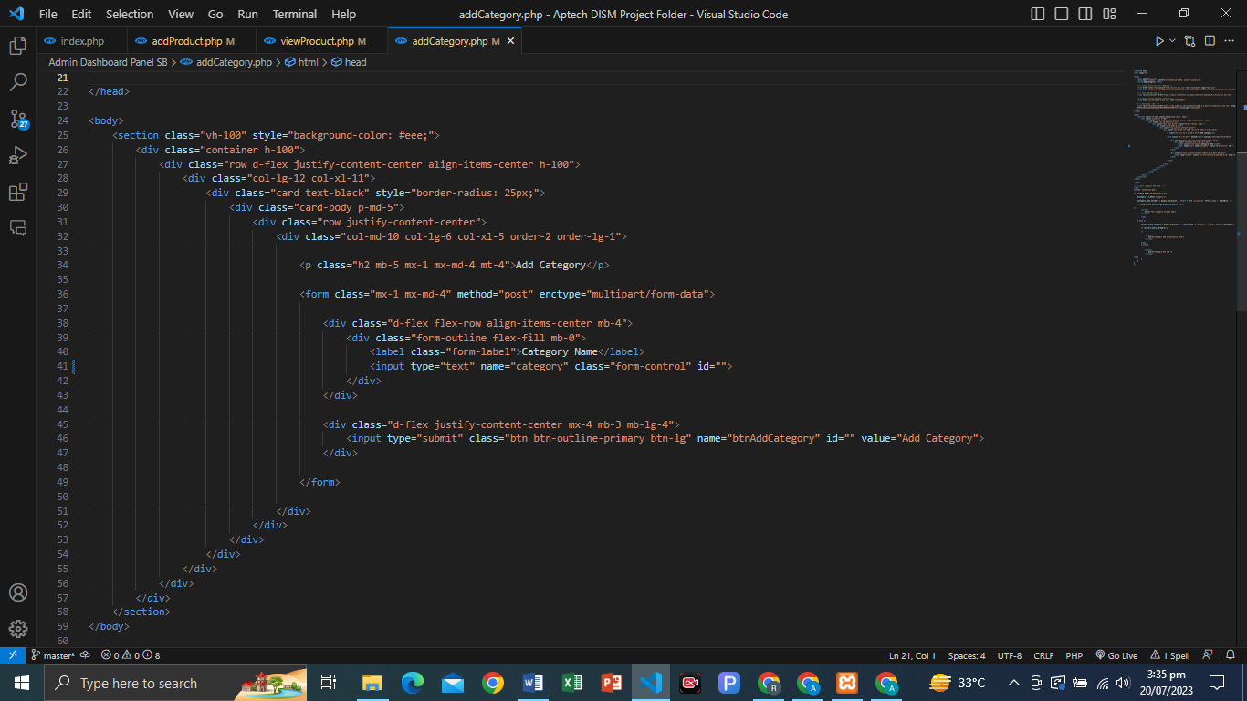

**Php Code ADD Category…!**

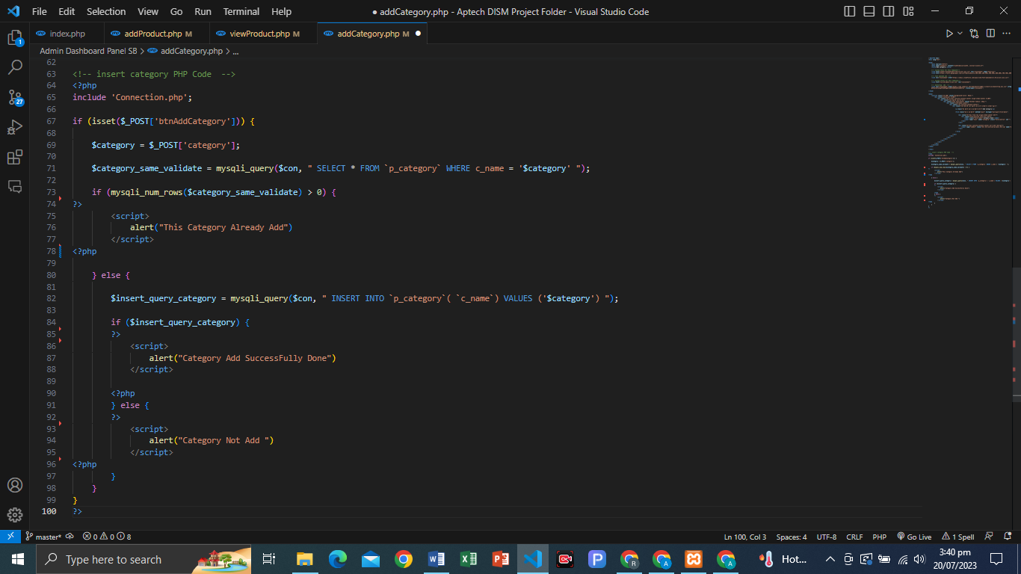

**MYSQL Category Table:**

